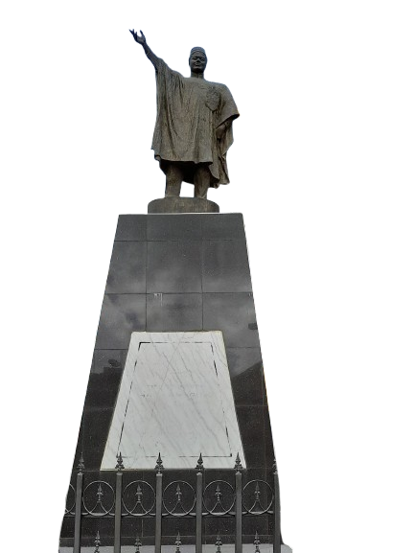
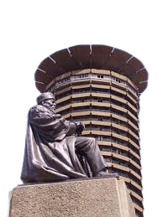
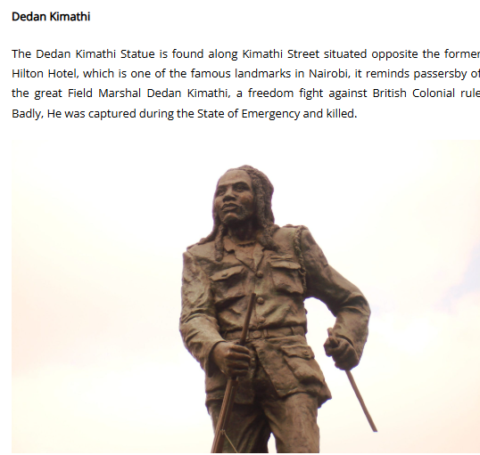
MONUMENTS IMAGES
Tom Mboya Monument
Jomo Kenyatta Monument
Dedan Kimathi Monument

